**DOCUMENTACIÓN PREVIA**

JdeRobot - Students: <https://jderobot.org/Students>

JMPlaza - Students: <https://jderobot.org/Students>

JdeRobot – Drones: <https://jderobot.org/Projects#Drones>

TFG Andrés de Jesús Hernández - Navegación visual autónoma de un drone real en 3D: <https://gsyc.urjc.es/jmplaza/students/tfg-drones-visual_follow_route-andres-2018.pdf>

TFG Jesús Sáinz Colomina - Programación de un dron para seguimiento autónomo de trayectorias en 3D: <https://gsyc.urjc.es/jmplaza/students/tfg-drone-3D_path_following-jesus_saiz-2018.pdf>

TFG Manuel Zafra Villar - Seguimiento de rutas 3D por un drone con autolocalización visual con balizas: <https://gsyc.urjc.es/jmplaza/students/pfc-drone_ruta3D-manuel_zafra-2017.pdf>

TFG Diego Jiménez Bravo - Drones con protocolo MavLink en el entorno JdeRobot: <https://gsyc.urjc.es/jmplaza/students/tfg-drones-mavlinkserver_diego-2018.pdf>

TFG Jorge Vela Peña - Despegue, navegación y aterrizaje visuales de un drone usando jderobot: <https://gsyc.urjc.es/jmplaza/students/tfg-drone_precise_landing-jorge_vela-2017.pdf>

**MavRos**

Página principal: <http://wiki.ros.org/mavros>

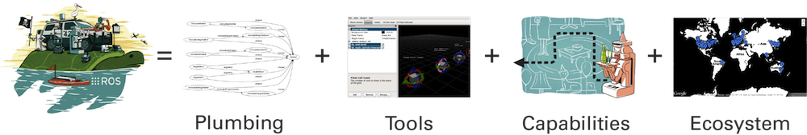

This package provides communication driver for various autopilots with MAVLink communication protocol. Additional it provides UDP MAVLink bridge for ground control stations (e.g. QGroundControl).

Github: <https://github.com/mavlink/mavros>

MavROS installation: <https://dev.px4.io/en/ros/mavros_installation.html>

MavROS with Gazebo simulator: <https://dev.px4.io/en/simulation/ros_interface.html>

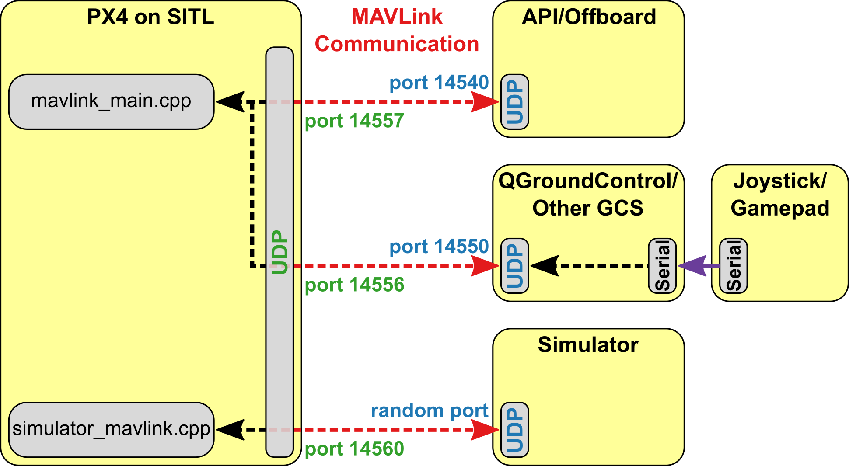

**MAVLink**

Wikipedia: <https://en.wikipedia.org/wiki/MAVLink>

MAVLink or Micro Air Vehicle Link is a protocol for communicating with small [unmanned vehicle](https://en.wikipedia.org/wiki/Unmanned_vehicle). It is designed as a header-only message marshaling library. MAVLink was first released early 2009[[1]](https://en.wikipedia.org/wiki/MAVLink#cite_note-1) by Lorenz Meier under [LGPL](https://en.wikipedia.org/wiki/LGPL) license.

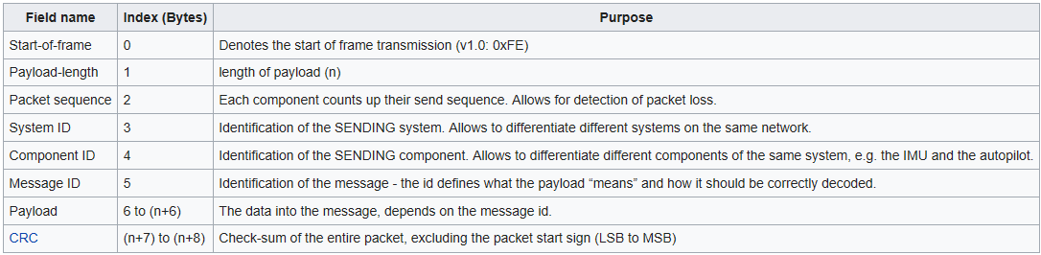

Introduction to MAVLink, Ardupilot and its Hardware Systems: <https://www.youtube.com/watch?v=qLfxzeKu2Hg>

MAVLink-based Ground Stations Overview: <https://www.youtube.com/watch?v=alcQphnT0pg>

MAVLink Developer Guide: <https://mavlink.io/en/>

MAVLink protocol overview: <https://mavlink.io/en/about/overview.html>

MAVLink commands: <http://ardupilot.org/dev/docs/mavlink-commands.html>

MAVLink tutorial for absolute dummies: [http://api.ning.com/files/i*tFWQTF2R*7Mmw7hksAU-u9IABKNDO9apguOiSOCfvi2znk1tXhur0Bt00jTOldFvob-Sczg3*lDcgChG26QaHZpzEcISM5/MAVLINK_FOR_DUMMIESPart1_v.1.1.pdf](http://api.ning.com/files/i*tFWQTF2R*7Mmw7hksAU-u9IABKNDO9apguOiSOCfvi2znk1tXhur0Bt00jTOldFvob-Sczg3*lDcgChG26QaHZpzEcISM5/MAVLINK_FOR_DUMMIESPart1_v.1.1.pdf)